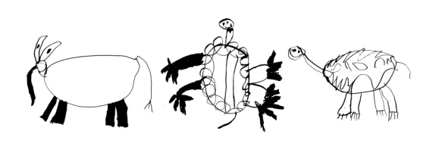

140 WALLACE HALL
BLACKSBURG, VA 24061
540/231.6148

CHILD DEVELOPMENT CENTER FOR LEARNING AND RESEARCH – DEPARTMENT OF HUMAN DEVELOPMENT

APPLICATION FOR FIELD STUDY
(Please complete this form and drop off or email a copy of your resume)

Name:
Address:
Phone:
Email:
Major:
Student I.D. Number:
Local Emergency Contact:

Previous Experience Working with Young Children:
Employer | Dates of Employment | Position | Job Description

- Describe why you want to work with young children. What are your career goals and how will this field study assist you with preparation for this future career?

- Describe how you would implement sanitary procedures to handle diapering, pottying, and other dealings with bodily fluids in the classroom.

- Describe how you would handle a conflict that emerges between children. For example, John and Sally are building with blocks. Sally takes the last of the blocks and John tries to grab the block from her. Sally then hits John. How would you approach this situation?

- Describe the role of the teacher in facilitating play and learning in the classroom.

- What are the most important aspects of the classroom environment? Describe components of a positive classroom climate.

- Describe professional behavior that you feel you would need to exhibit to be successful in this work environment.

- If you were offered this placement, which age groups would you be interested in working with?
______ Toddlers (15-30 months)

_____ Younger Preschoolers (30-48 months)

_____Older Preschoolers (48-60 months)

List the days/times you would be available/interested in volunteering:

References:

